Voltage Sweep Comparison: run12, run13, run14, run15, run16, run17, run18
Parameters held constant: 2mA ion + 2mA electron current, 800K particles each, deuterium ions, h=0.3mm mesh, 10-iter cap, convergence threshold = 0.1% of |cathodepot|.

1. Overview
Run | Voltage (kV) | Converged (Y/N) | Iterations to converge | Final Epot error (V) | Avg trajectory steps | Central potential (V) | Central anode height (%)
run12 | 10 | Y | 2 | 0.0000 | 61059380 | -9313.60 | 6.864
run13 | 20 | Y | 2 | 0.0000 | 67042812 | -18627.20 | 6.864
run14 | 30 | Y | 2 | 0.0000 | 70468901 | -27940.90 | 6.864
run15 | 40 | Y | 2 | 0.0000 | 73238549 | -37254.40 | 6.864
run16 | 50 | Y | 2 | 0.0000 | 75155952 | -46568.00 | 6.864
run17 | 75 | Y | 2 | 0.0000 | 79108320 | -69851.80 | 6.864
run18 | 100 | Y | 2 | 0.0000 | 81842059 | -93136.10 | 6.864

2. Superimposed Radial Potential Profiles (x, y, z)
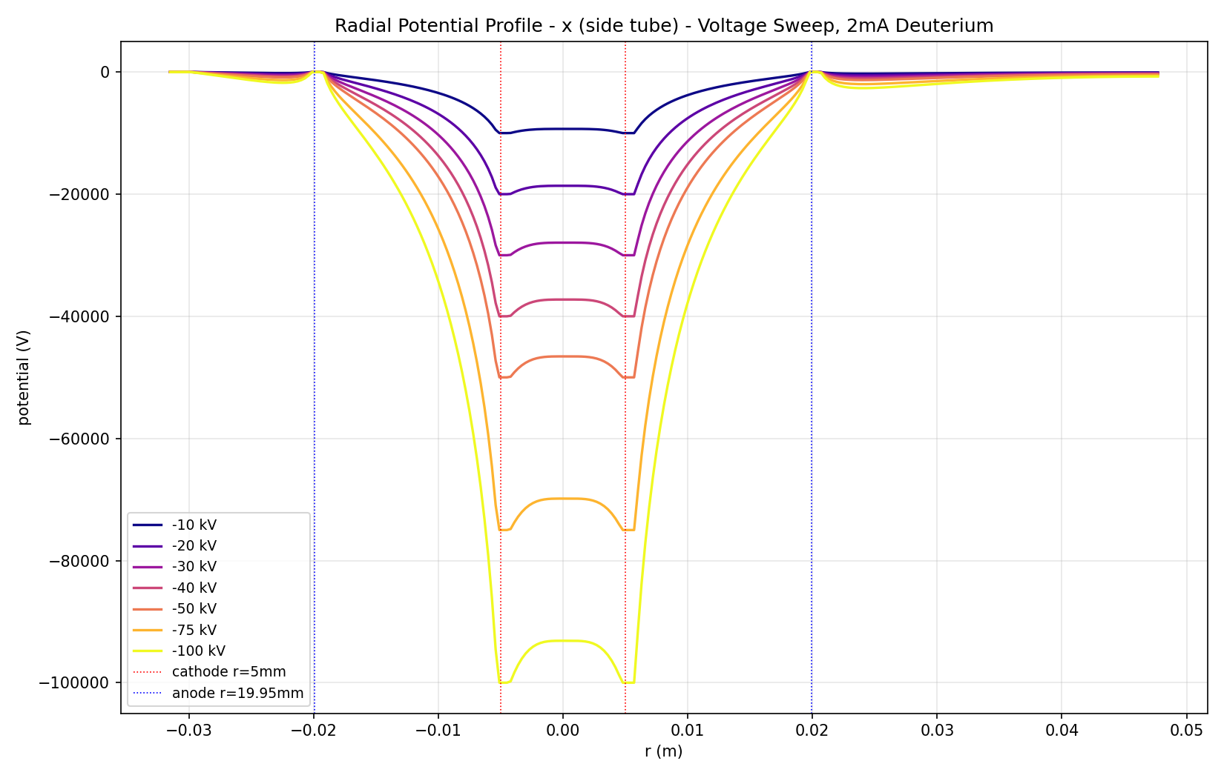
x (side tube) axis - final iteration per run
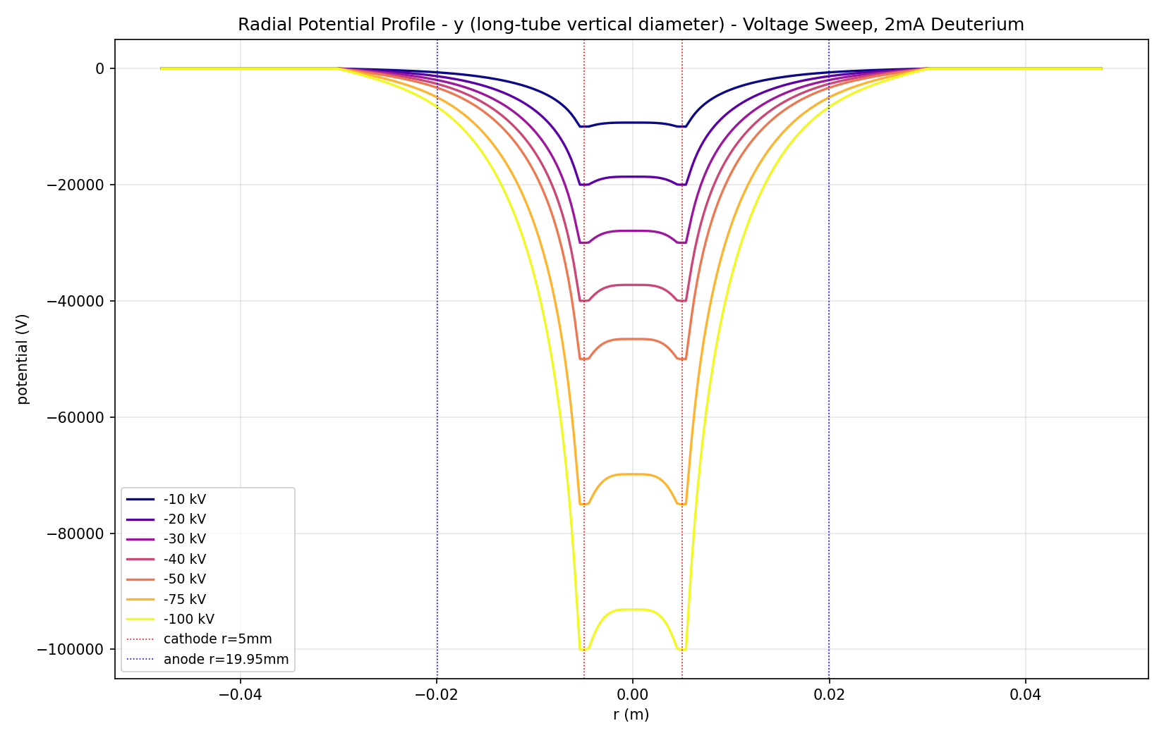
y (long-tube vertical diameter) axis - final iteration per run
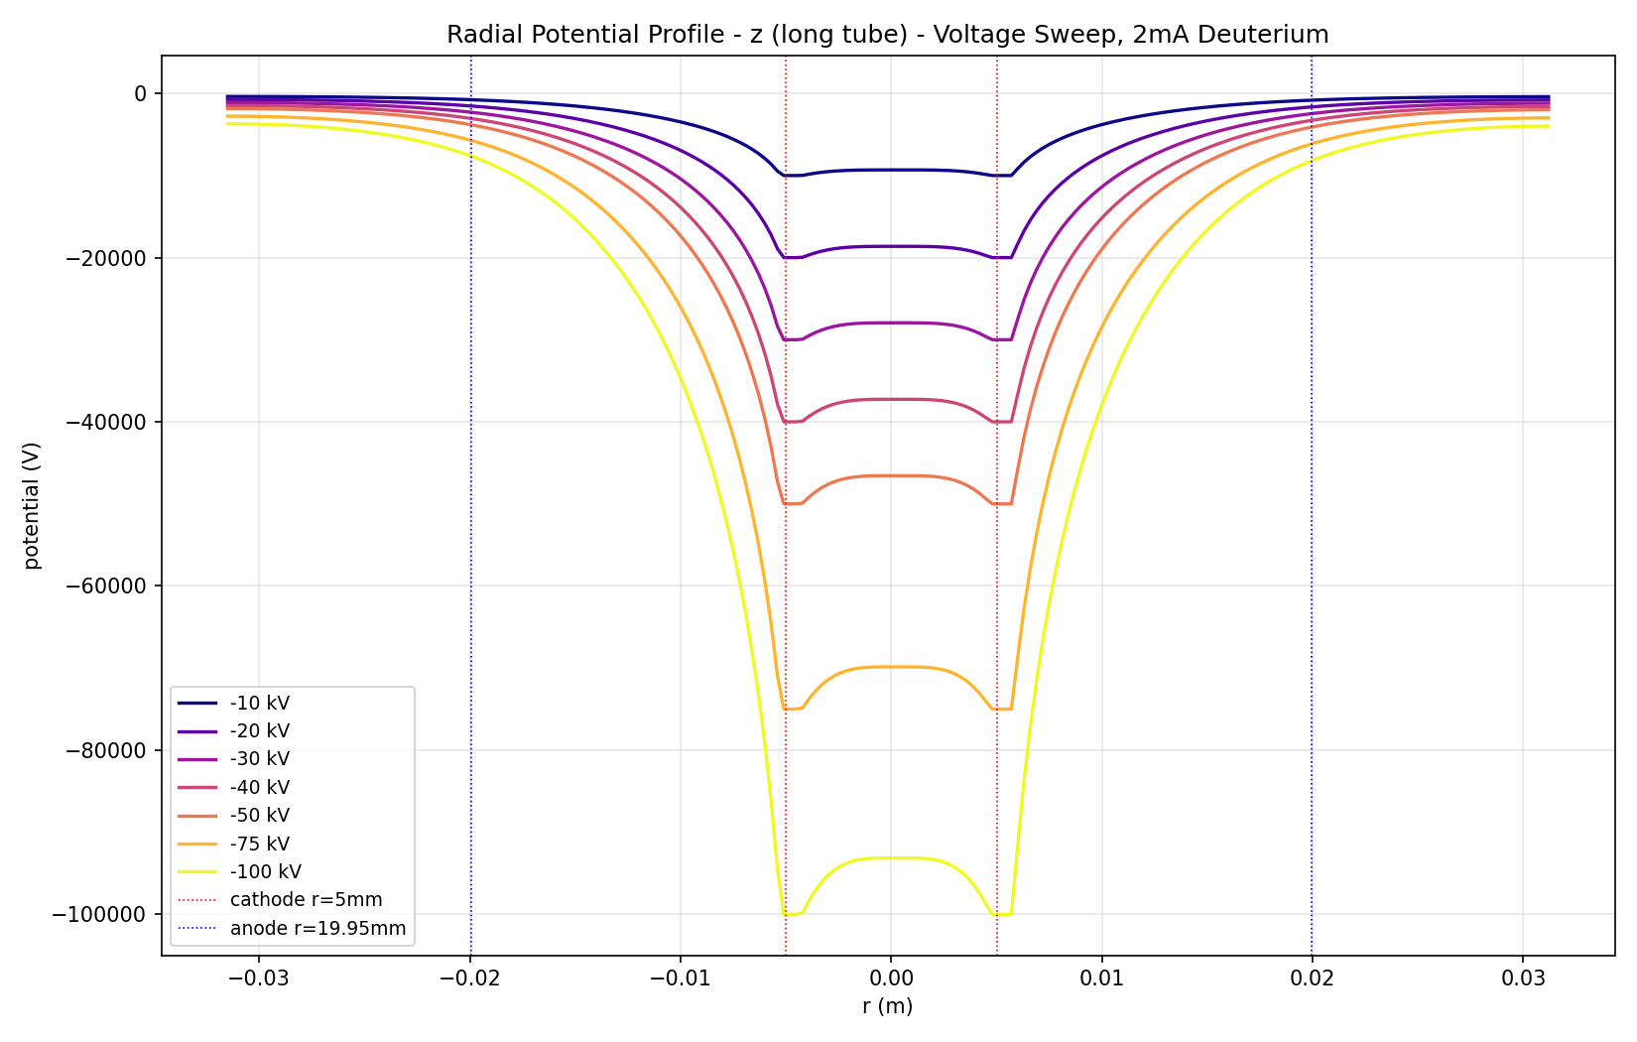
z (long tube) axis - final iteration per run

3. Superimposed Convergence
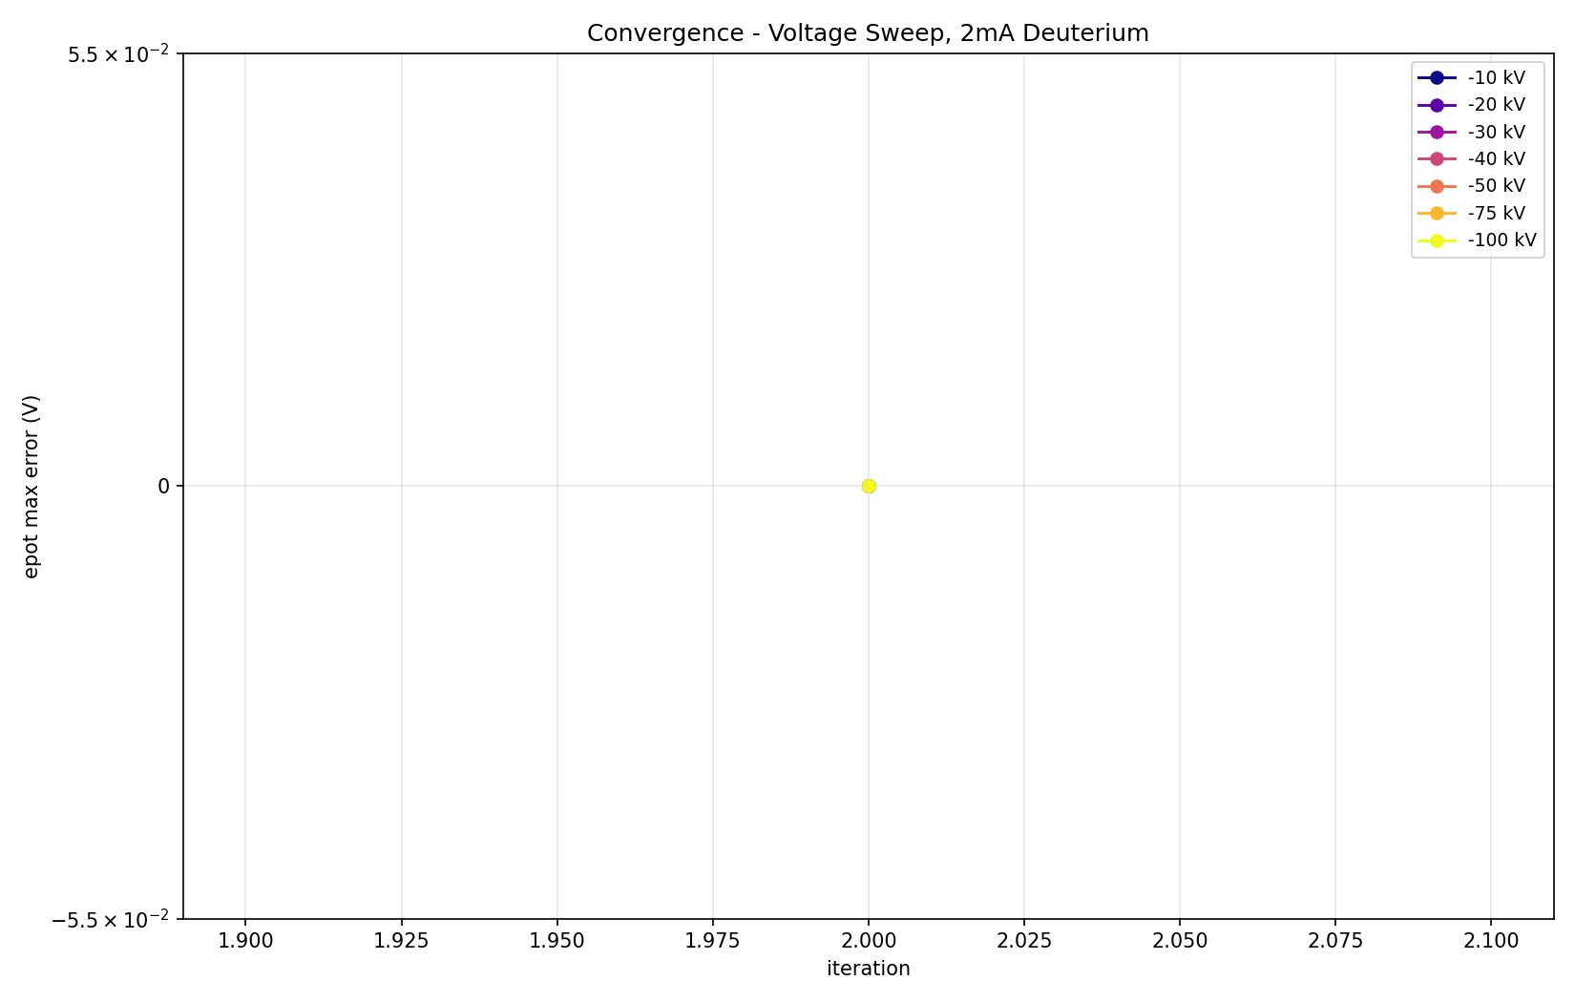

4. Trajectory Density Comparison (trajdens_xz)
-10 kV  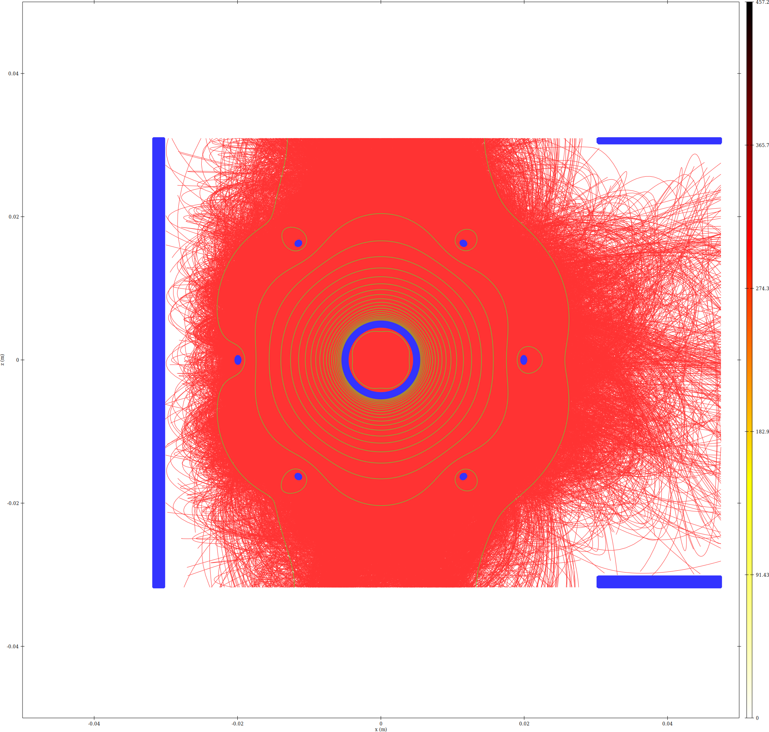 | -20 kV  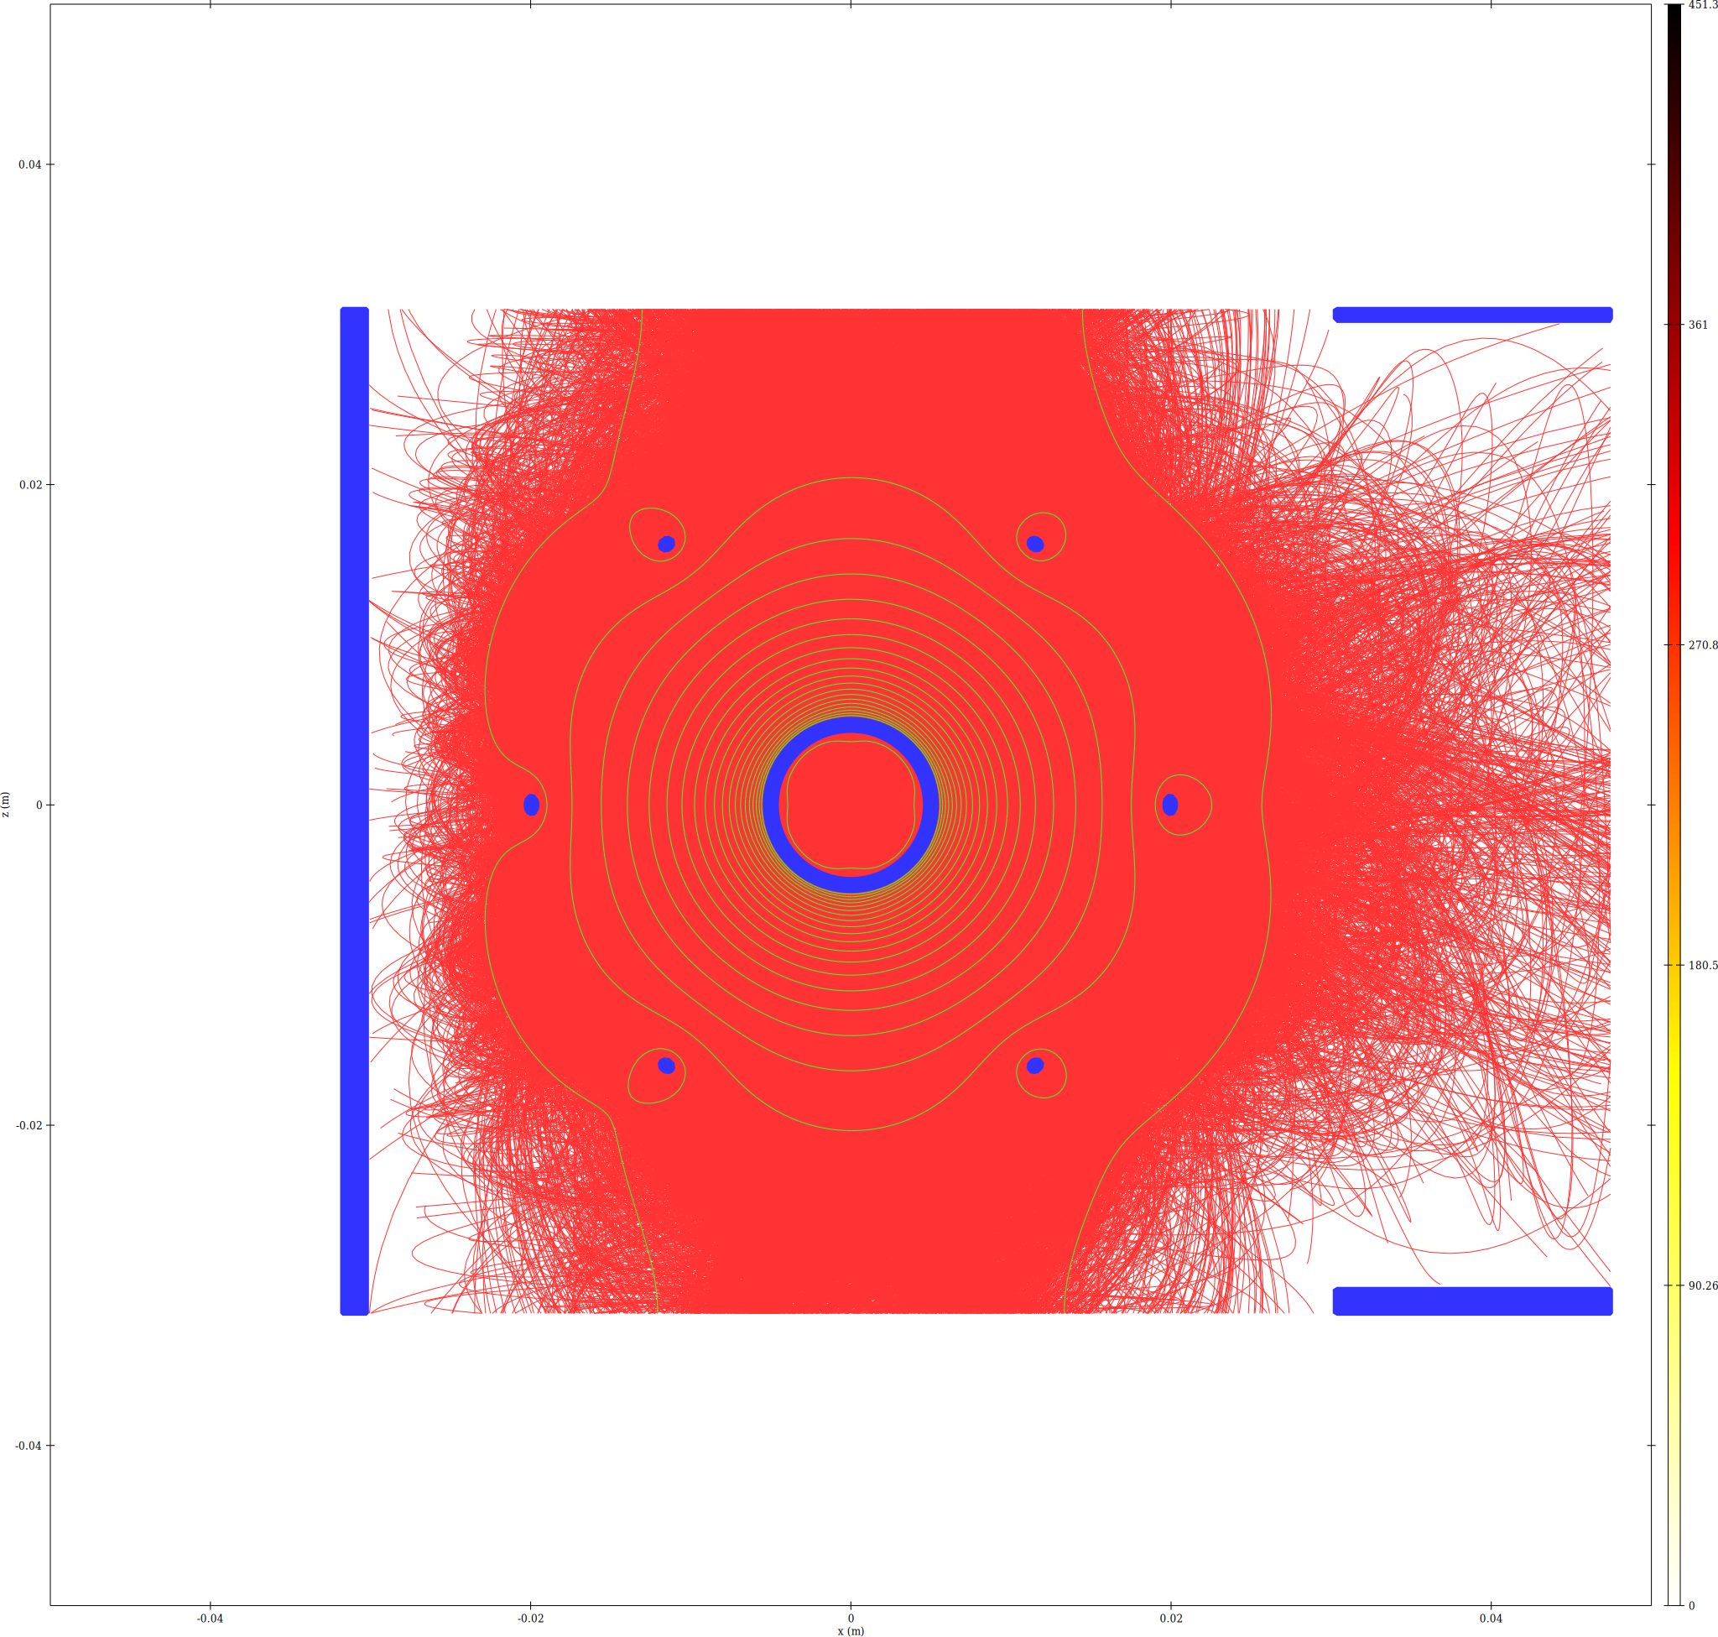
-30 kV  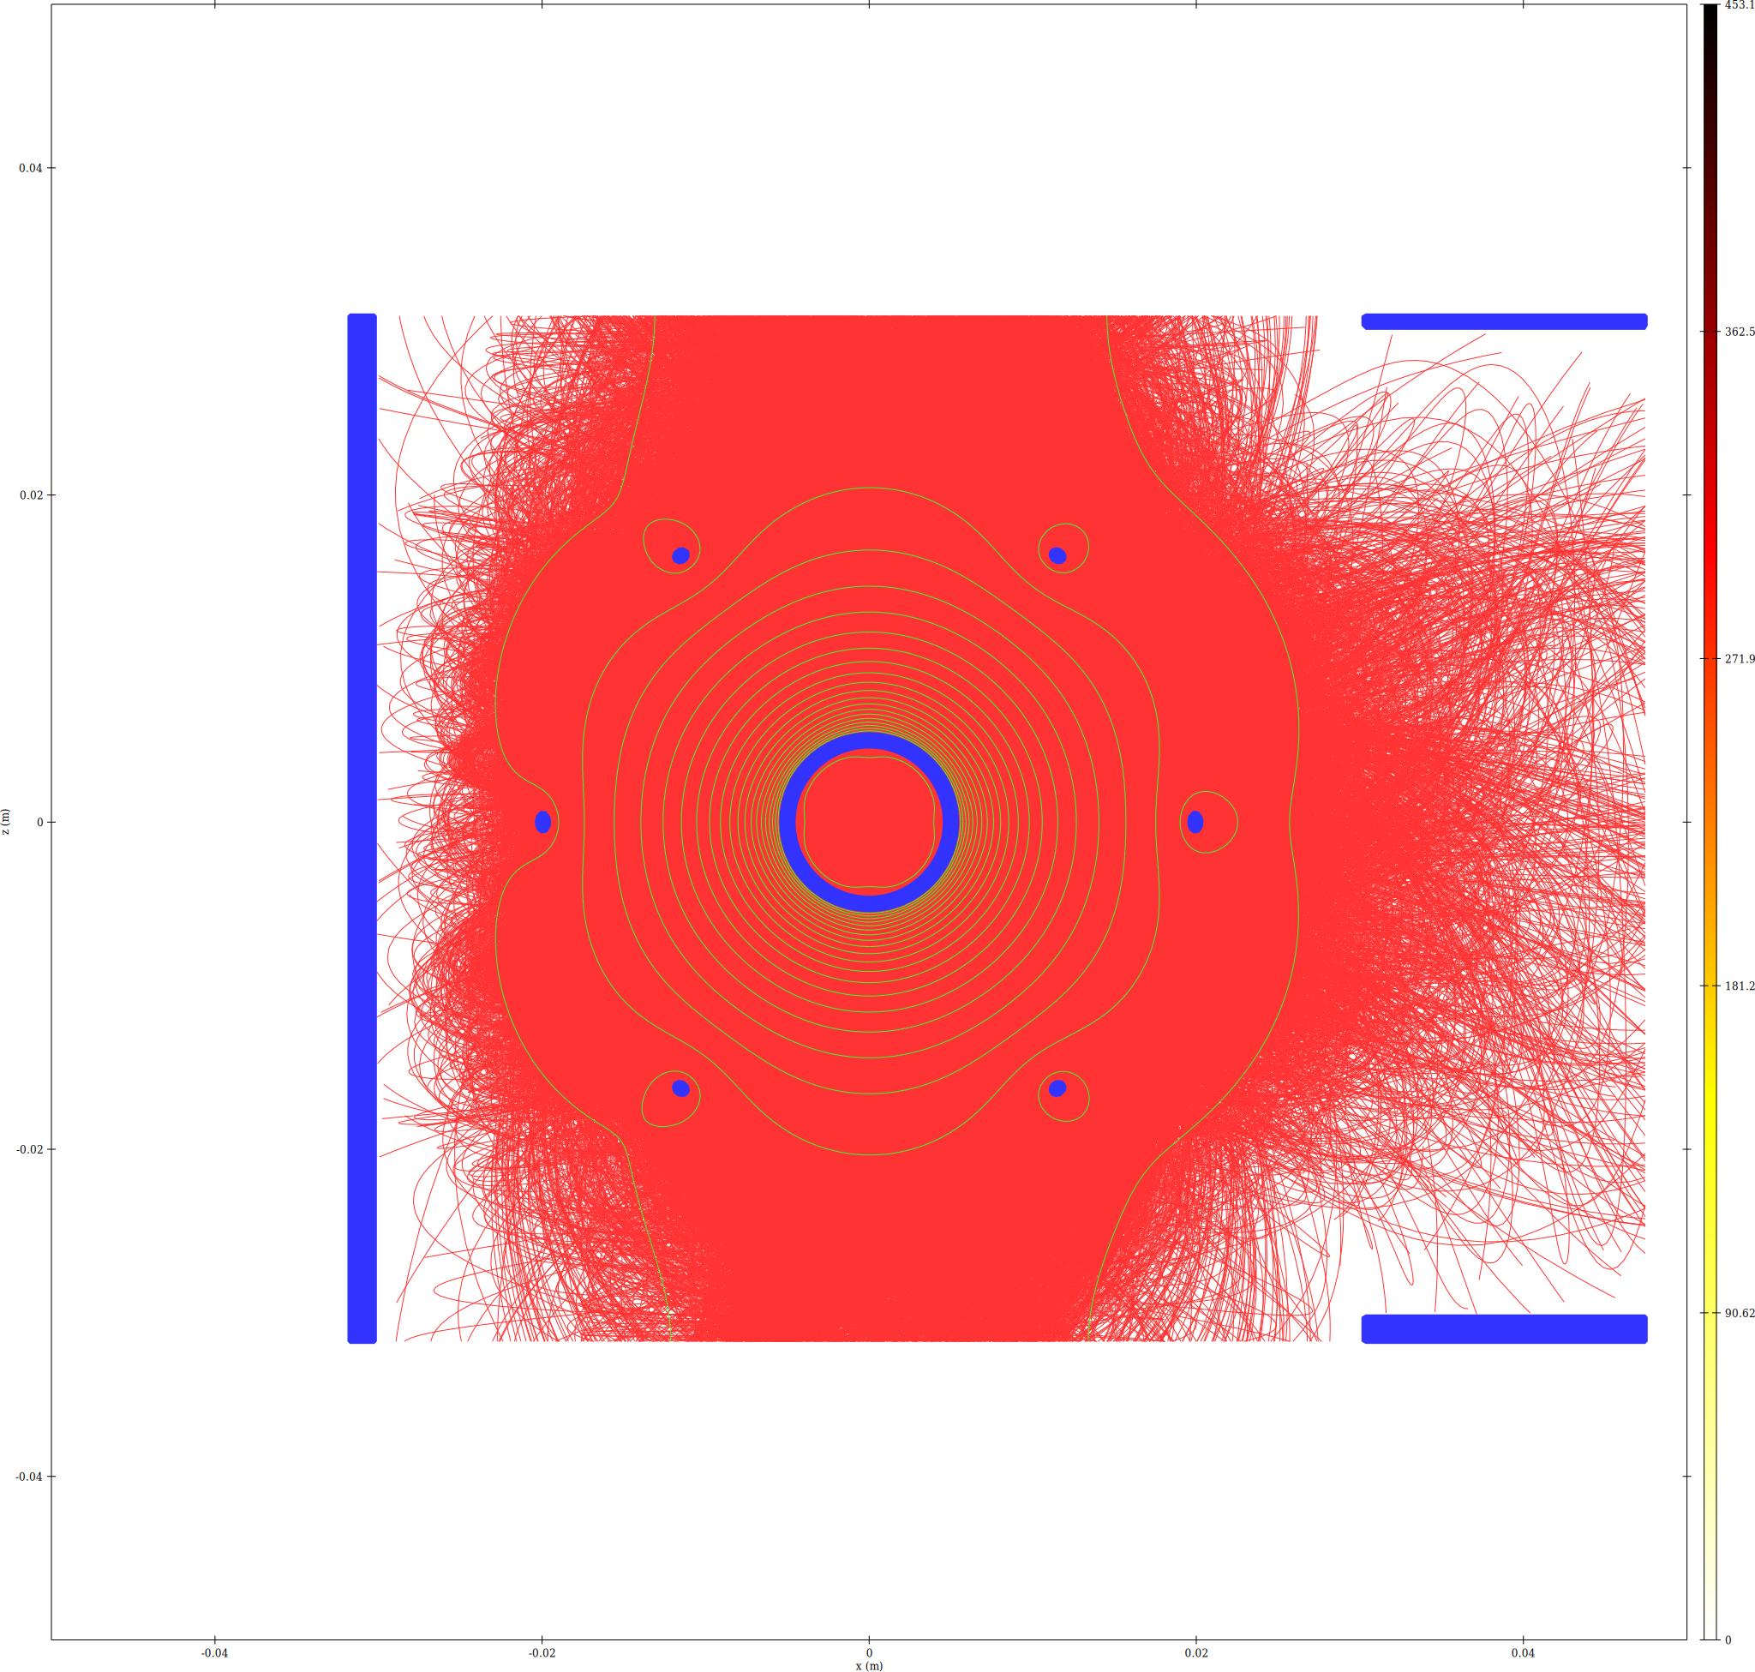 | -40 kV  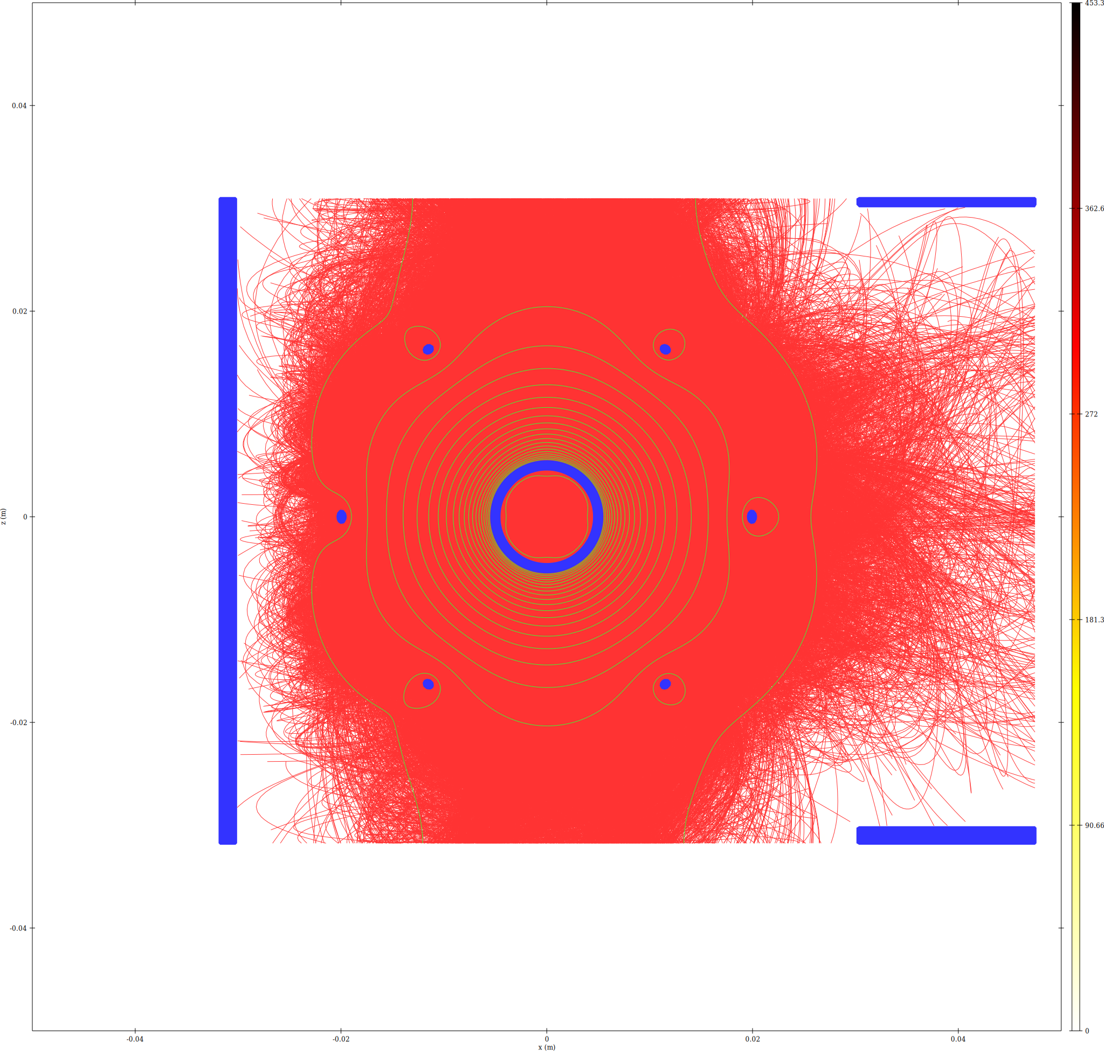
-50 kV  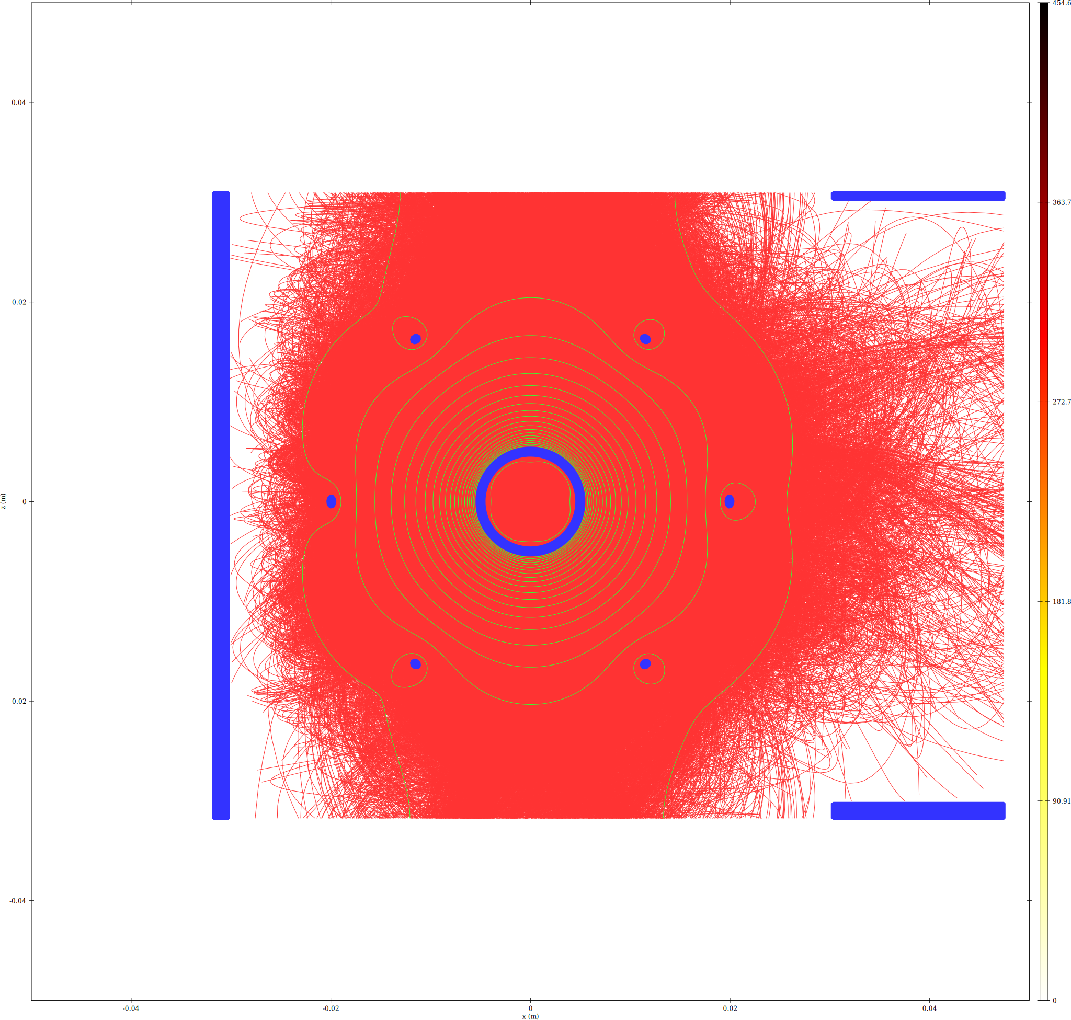 | -75 kV  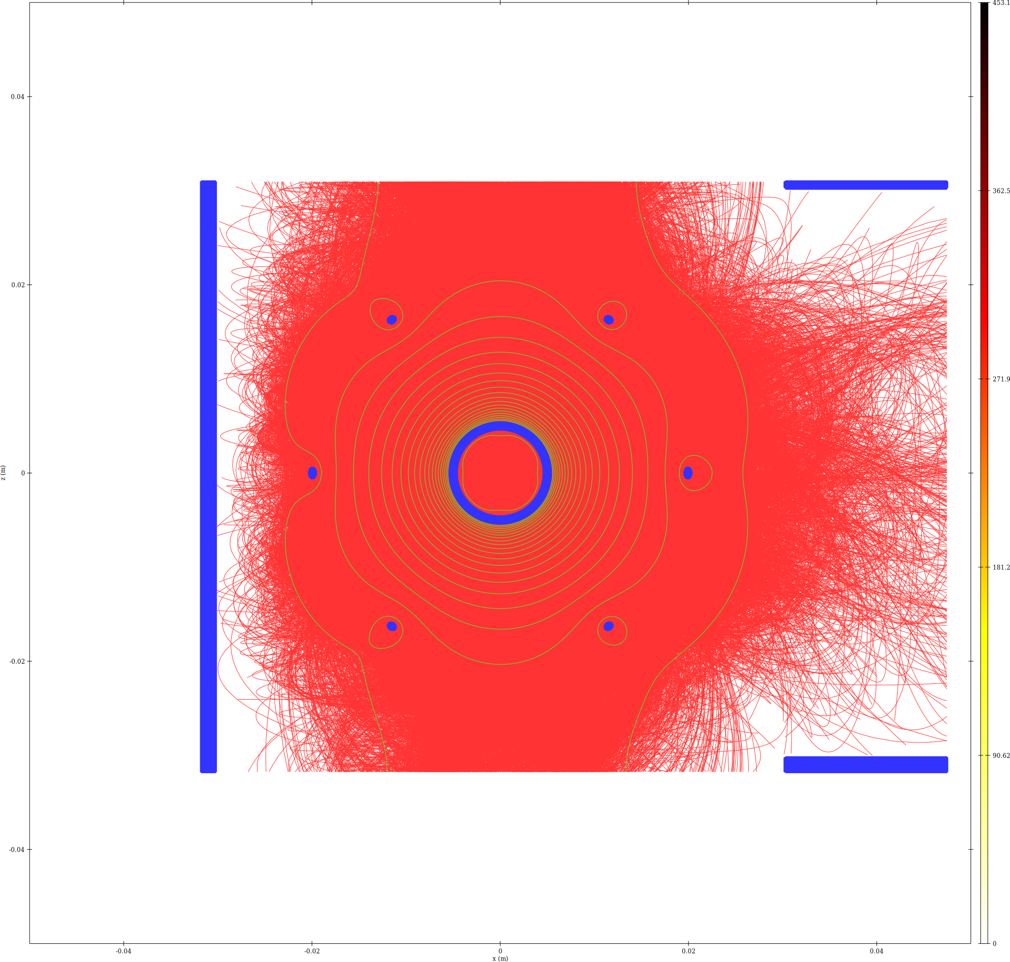
-100 kV
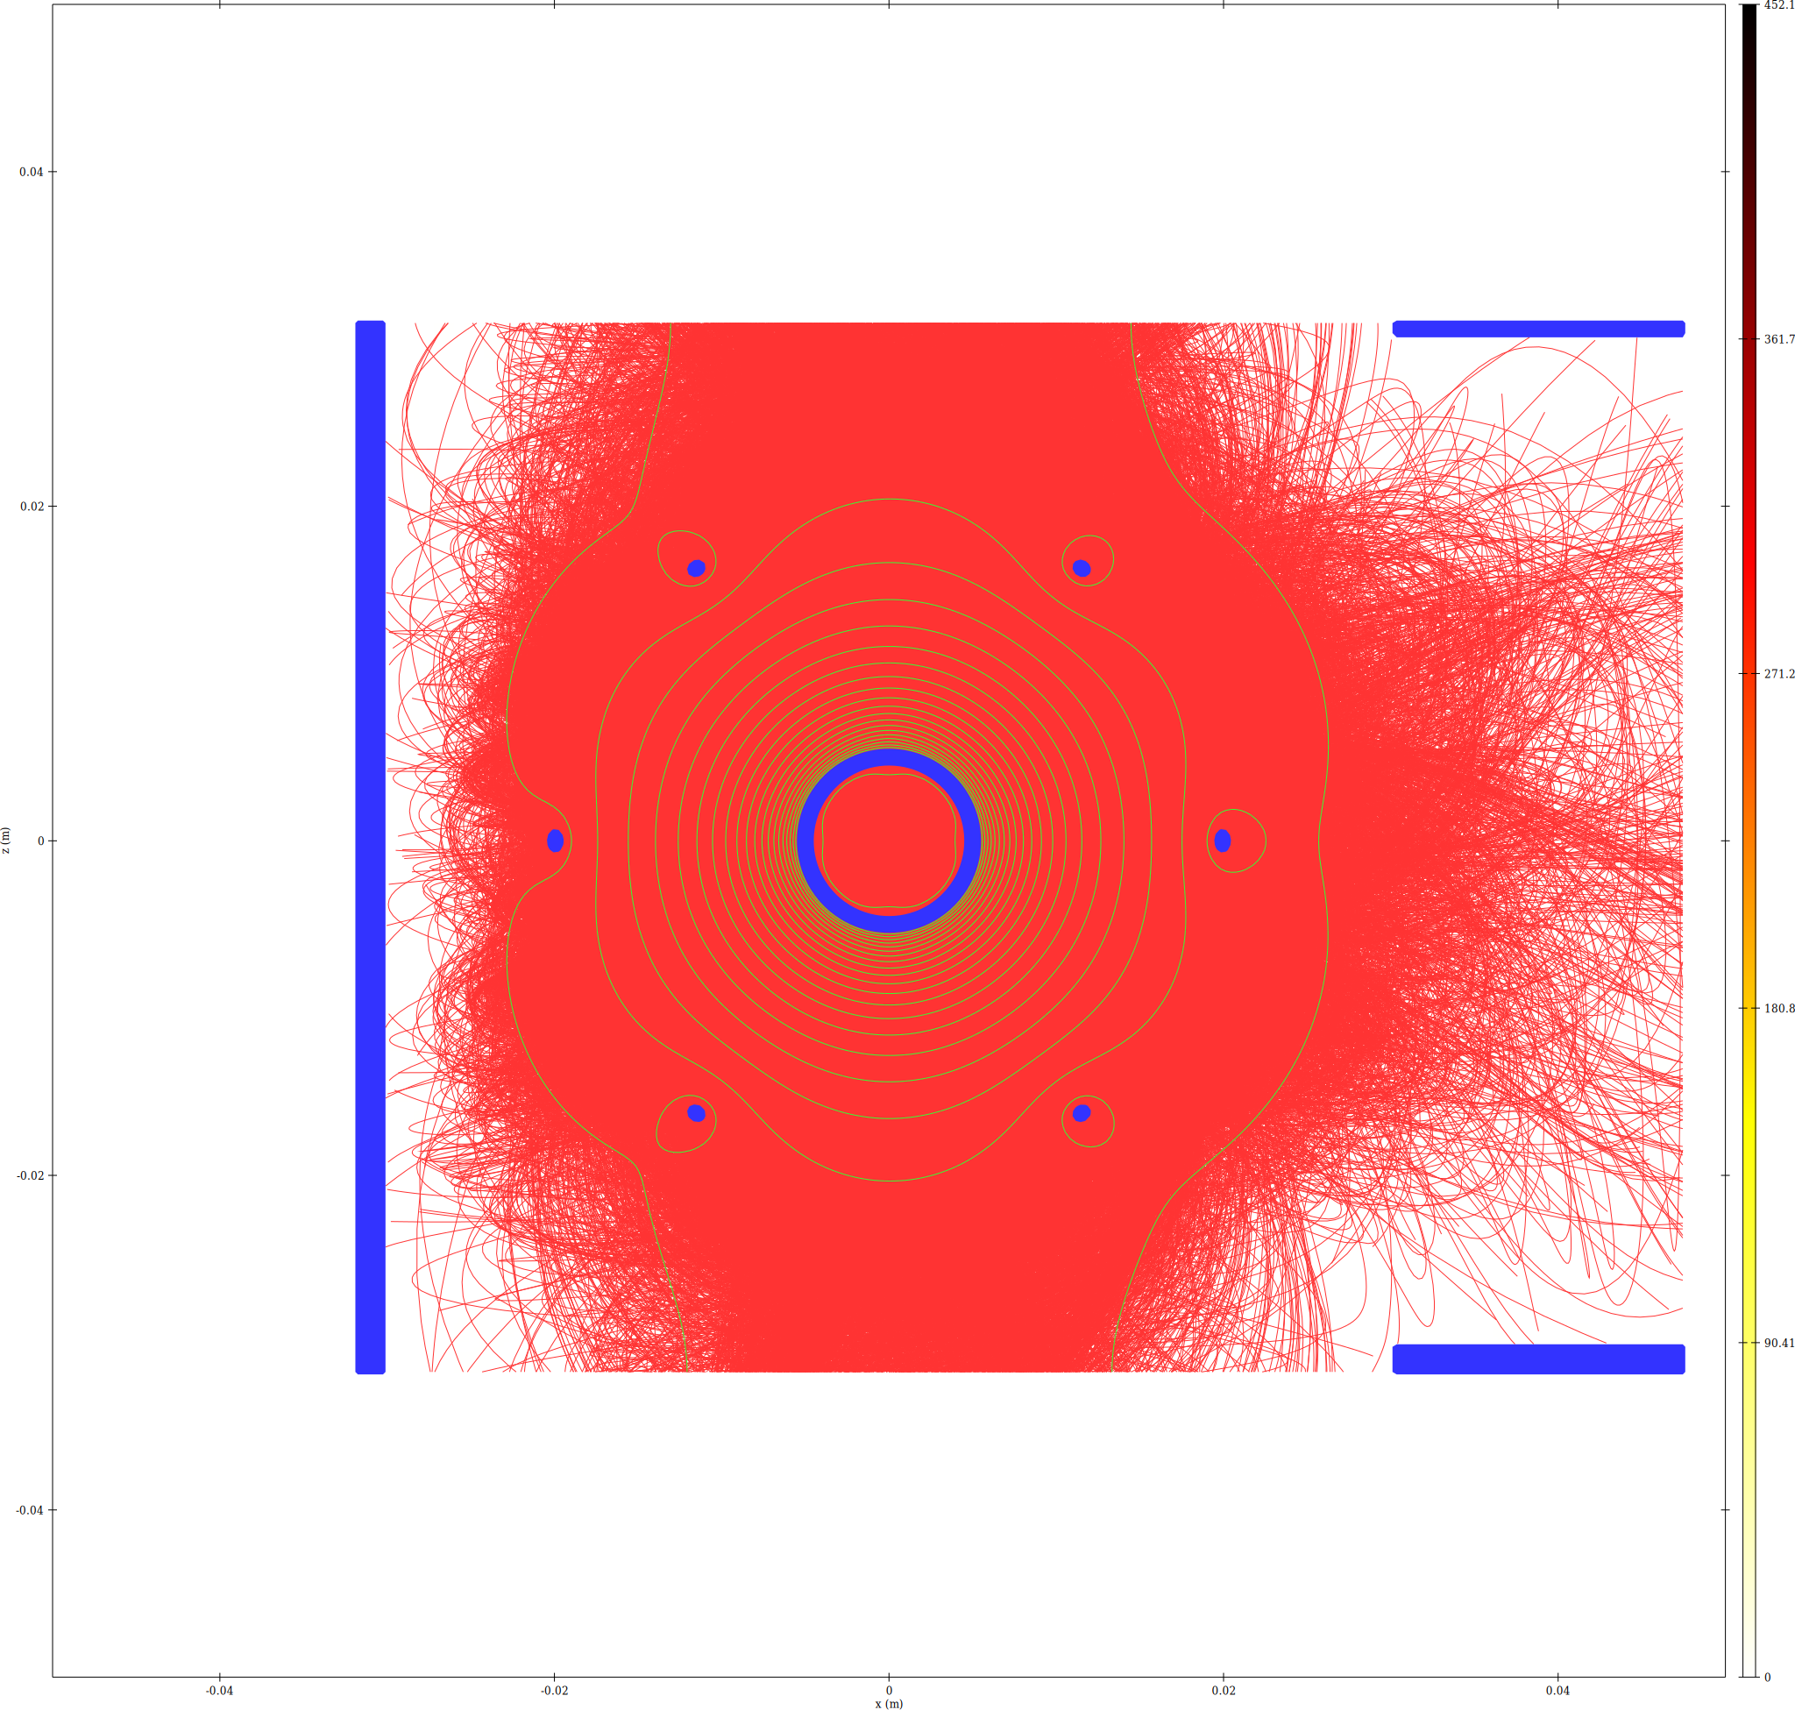

5. Final Potential Field Comparison (epot_xz)
-10 kV  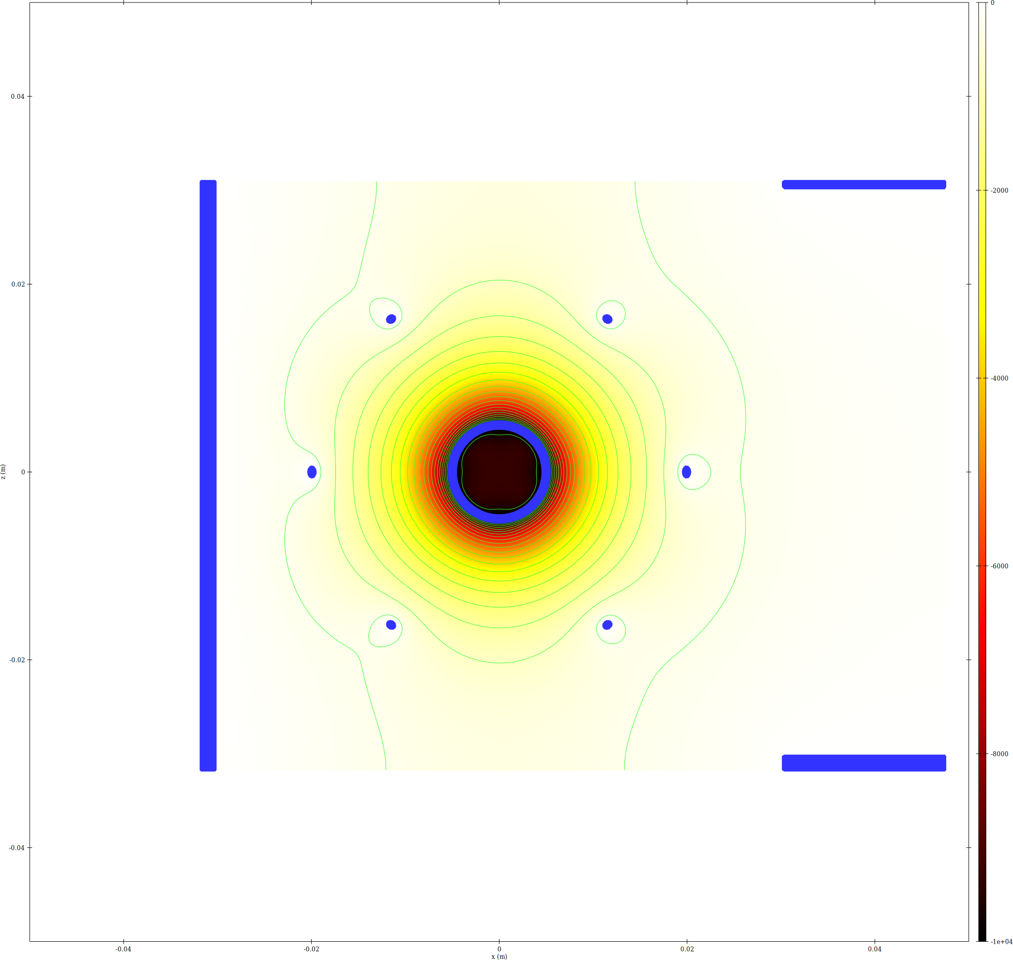 | -20 kV  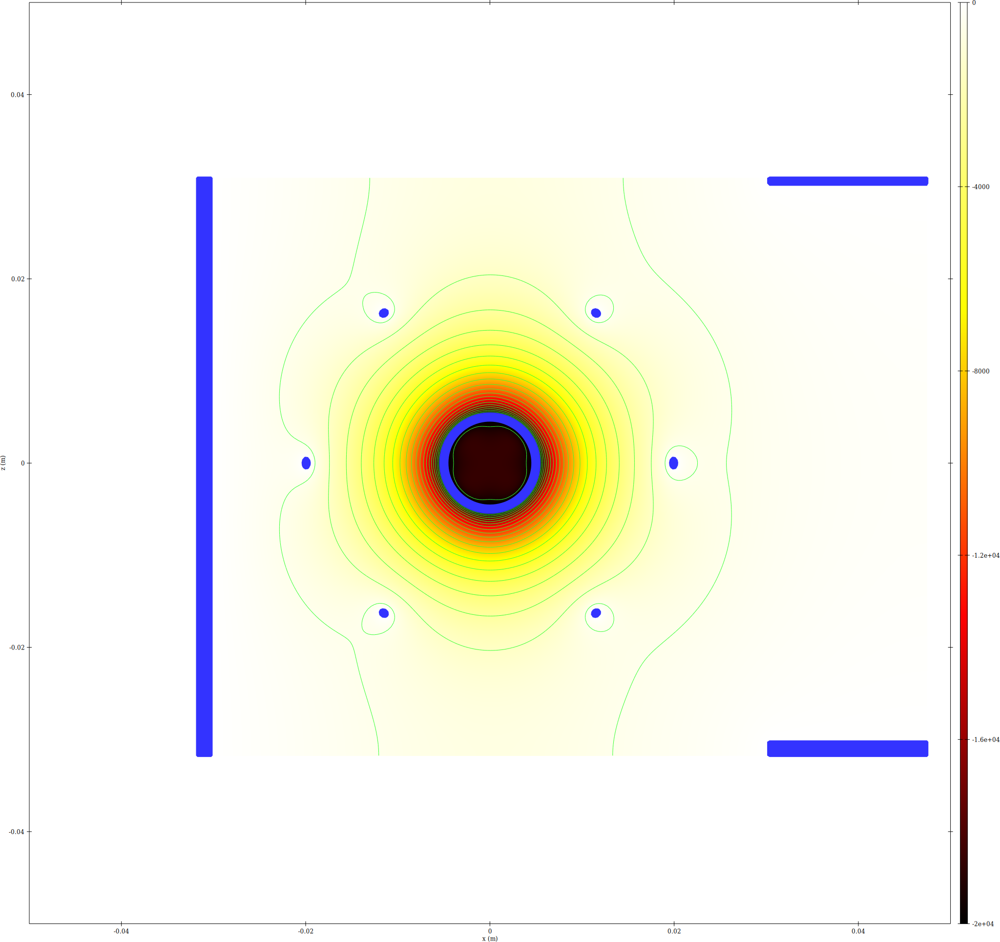
-30 kV  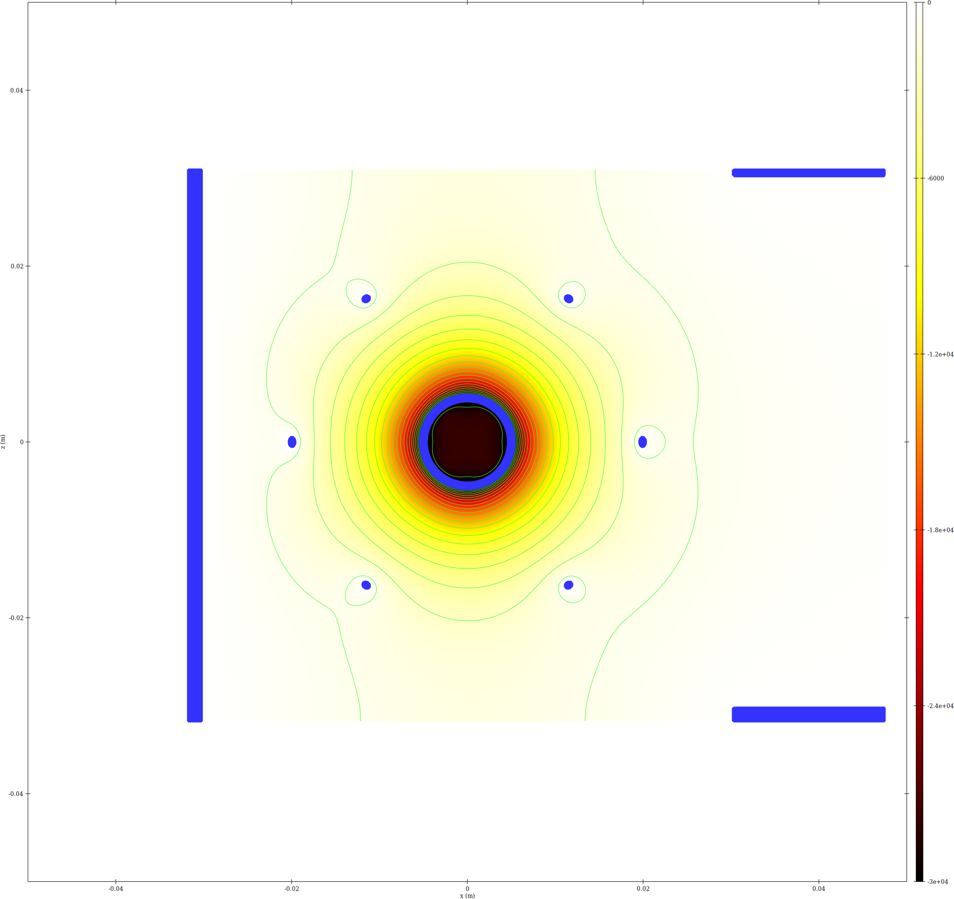 | -40 kV  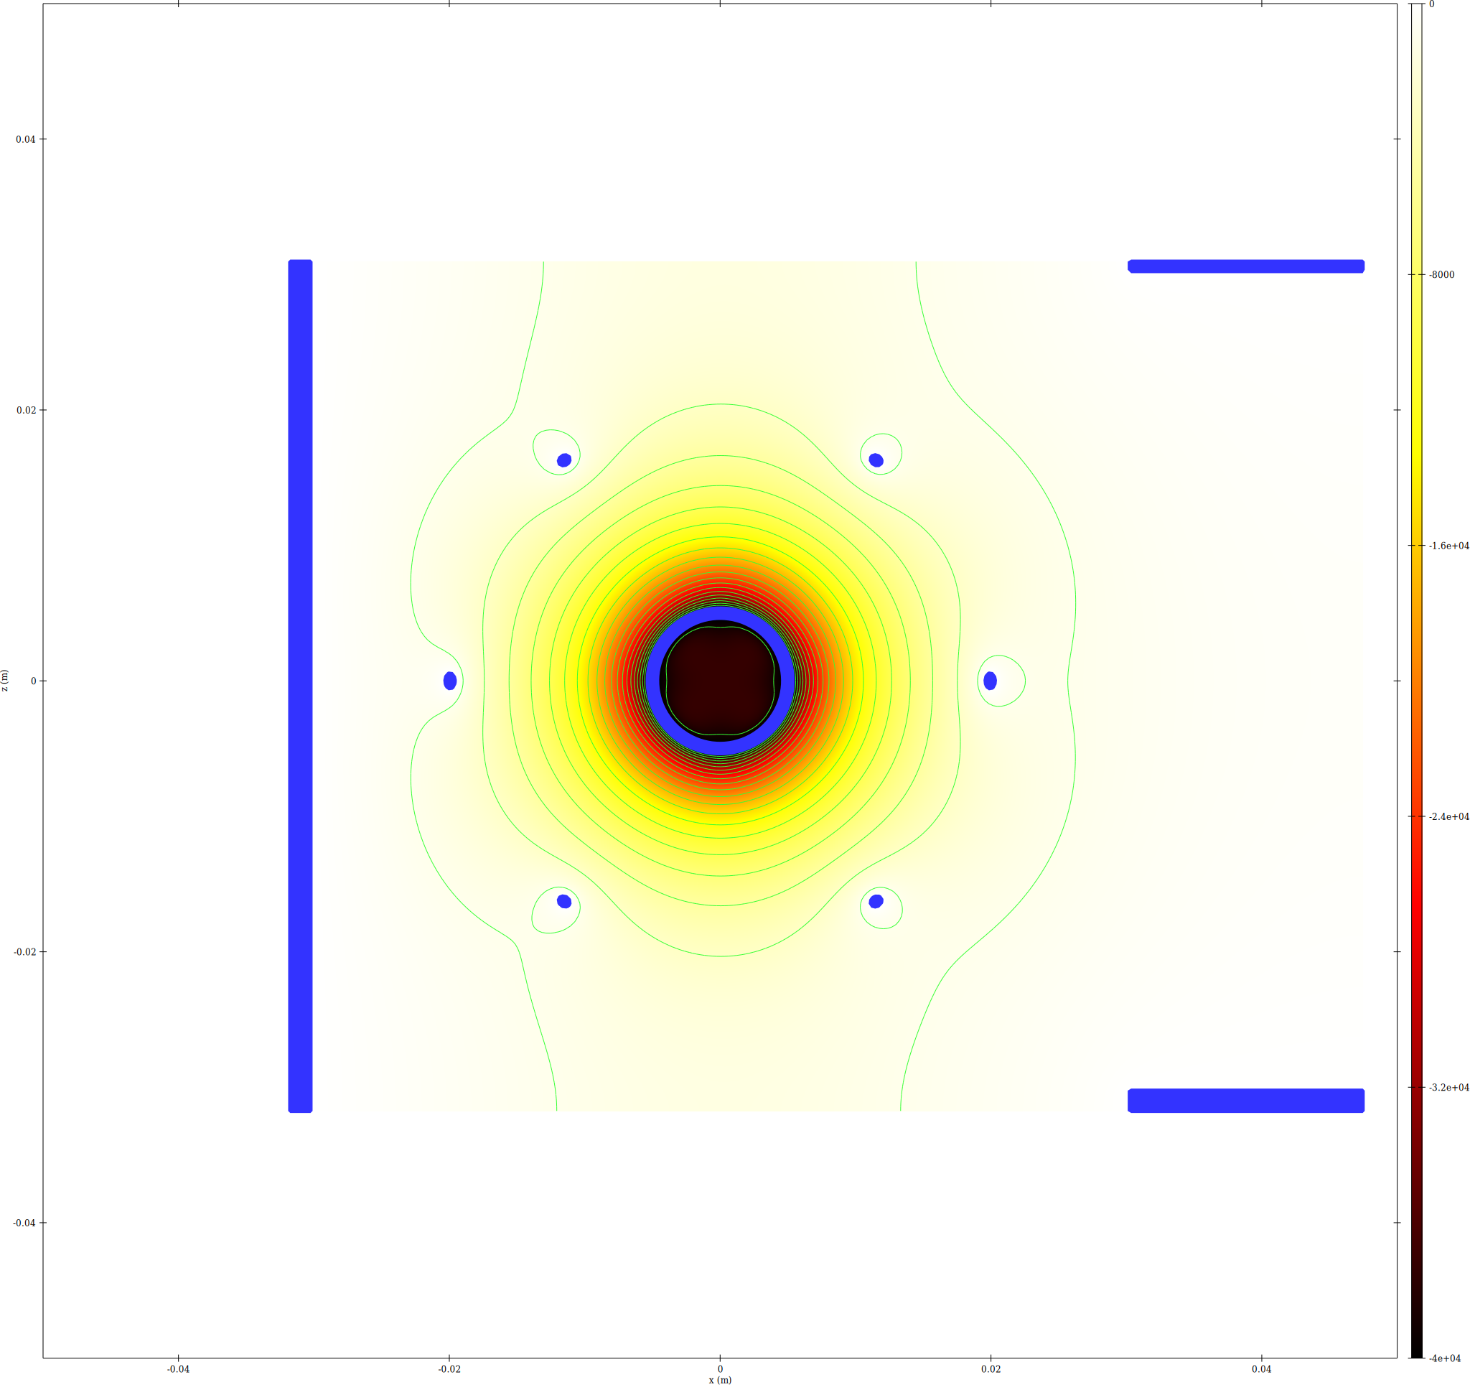
-50 kV  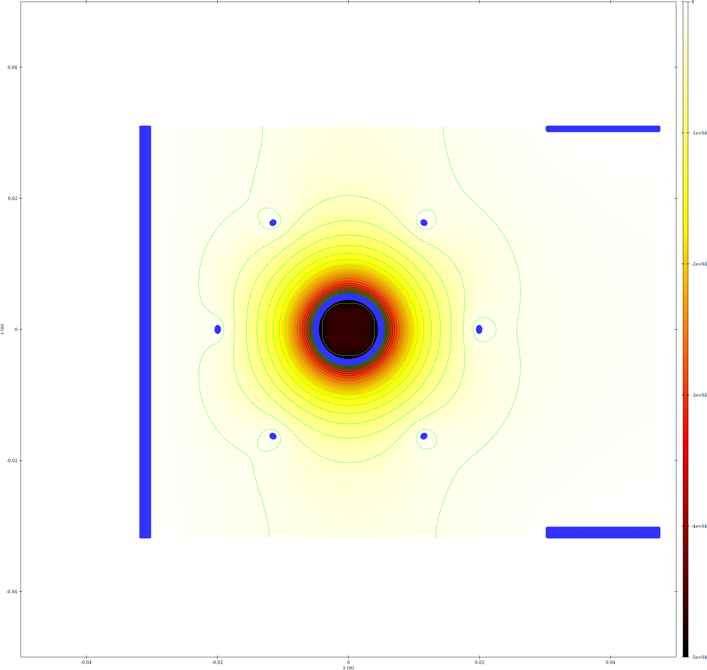 | -75 kV  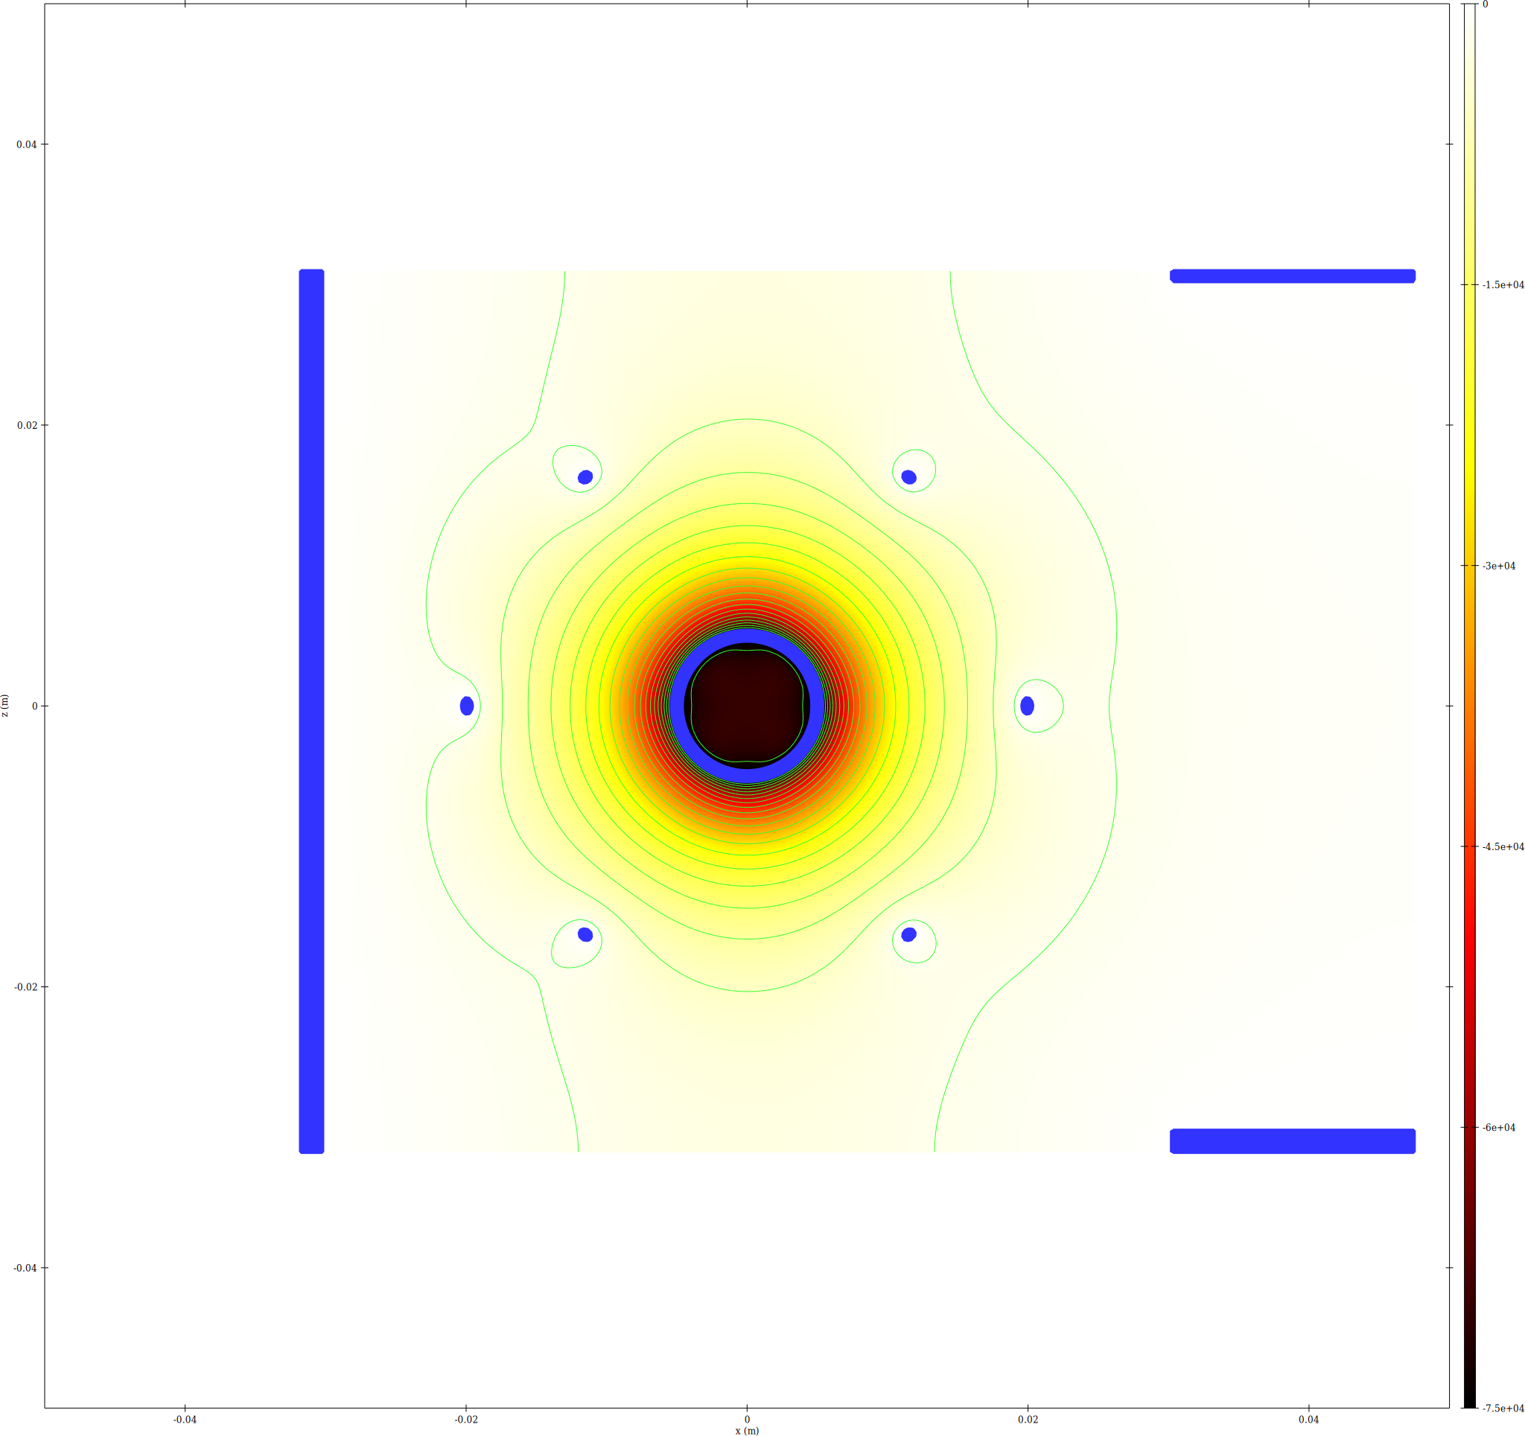
-100 kV
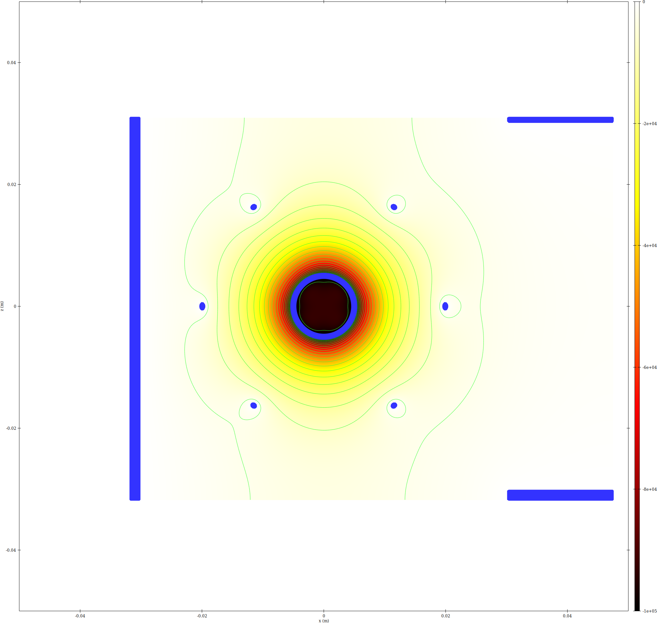

6. Memory Summary
Run | Voltage (kV) | Final iter | Ion steps | Electron steps | Total GB
run12 | 10 | 2 | 61035438 | 31386933 | 7.8338
run13 | 20 | 2 | 67009202 | 31588628 | 8.1558
run14 | 30 | 2 | 70473211 | 31672599 | 8.3409
run15 | 40 | 2 | 73276167 | 31726376 | 8.4899
run16 | 50 | 2 | 75157241 | 31760586 | 8.5898
run17 | 75 | 2 | 79128998 | 31819132 | 8.7999
run18 | 100 | 2 | 81787441 | 31853037 | 8.9404

